This laboratory assignment accompanies the book, [*Embedded Systems: Real-Time Interfacing to ARM Cortex M Microcontrollers, ISBN-13: 978-1463590154*](https://www.amazon.com/Embedded-Systems-Real-Time-Interfacing-Microcontrollers/dp/1463590156), by Jonathan W. Valvano, copyright © 2021.

## Goals

* To interface a DC motor using PWM so software can adjust delivered power
* To interface a tachometer so the software can measure speed
* To implement the data acquisition with input capture interrupts
* To implement the digital controller processing with periodic interrupts
* To study the behavior of the system as parameters to the proportional-integral (PI) controller are adjusted

## Responsibilities:

* Student 1: Tach hardware and input capture measurement of speed
* Student 2: Motor and interface hardware and PWM output
* Student 3: Digital Controller
* Student 4a: User interface (Blynk, UART, LCD)
* Student 4b: User interface UART0 to PC, command interpreter
* ALL: Tinker with variations of the PI control loop

**Team Size: 4**



Figure 10.1: Lab 10G Block Diagram.

## Review

* Valvano Section 6.1.3 about using input capture to measure period
* Valvano Section 6.3 about generating PWM outputs
* Valvano Section 6.5 about interfacing a DC motor with a IRLD024 or IRLD120
* [IRLD120 data sheet](https://www.dropbox.com/s/ulcq0selng2aqfx/IRLD120.pdf?dl=1)
* [IRLD024 data sheet](https://www.dropbox.com/s/u49pvrn8jz70aru/sihld24.pdf?dl=1)
* Pololu motor <https://www.pololu.com/product/3675>
* Valvano Section 6.6 about integral control (you will need to add [proportional control](https://www.et.byu.edu/~tom/classes/436/ClassNotes/Class07-PI.pdf))

## Starter files

* PWM_4C123 PeriodMeasure_4C123
* PeriodicTimer0AInts_4C123
* Python starter code <https://www.dropbox.com/s/6zvz0f4lu4efaa8/Python.zip?dl=1>
* [Lab 10G Eagle starter Schematic](https://www.dropbox.com/s/pyssg7koidkfg54/Lab10_Starter.sch?dl=1)
* EE445M <http://users.ece.utexas.edu/%7Evalvano/arm/MotorTestProject.zip>
* EE445M <https://www.dropbox.com/s/vtjc5j6hz9b15dj/SensorTestProject.zip?dl=1>

## Required Hardware (hardware groups building with discrete parts)

EK-TM4C123GXL [https://store.ti.com/](https://store.ti.com/ProductAccessories.aspx?ProductId=4505) $12.99

Sitronix ST7735 Color LCD <http://www.adafruit.com/products/358> $19.99

Pololu item #3675 <https://www.pololu.com/product/3675> $13.95

1N914B 4ns switching diode

Two 10k resistors

IRLD024 or IRLD120 MOSFET

## Background

The advantages of DC motors include low cost, high speed, and high torque. However, they need sensors and closed-loop controllers in order to operate them with predictable responses. Applications of DC motors include electric cars, robotics, industrial machines (pumps, drills, mills, and lathes), consumer products (blender, washing machine, and AC/heaters) and medical devices (pumps). In this lab, you will spin a brushed DC motor (Figure 10.2) at a constant speed using a proportional-integral (PI) controller. The user interface will allow the operator to increase or decrease the desired speed. A tachometer will be used to measure the motor speed. A background periodic interrupt will execute the three steps of a digital controller.

1. Calculate error as the difference between actual and desired speed
2. Execute a control equation to determine the next output
3. Adjust the power to the actuator in an attempt to drive the error to zero

The software will set the power delivered to the motor using pulse-width-modulation (PWM). The essence of an integral controller is the amount you add to the power is linearly related to the error. If the motor is spinning much too slowly, you will increase power a lot. If the motor is spinning just a little bit too slowly, you will increase power a little bit. If the motor is spinning much too quickly, you will decrease power a lot. If the motor is spinning just a little bit too quickly, you will decrease power a little bit. The input capture input and the PWM output must be written at a low level, like the book, without calling TivaWare driver code. No TivaWare code is allowed.

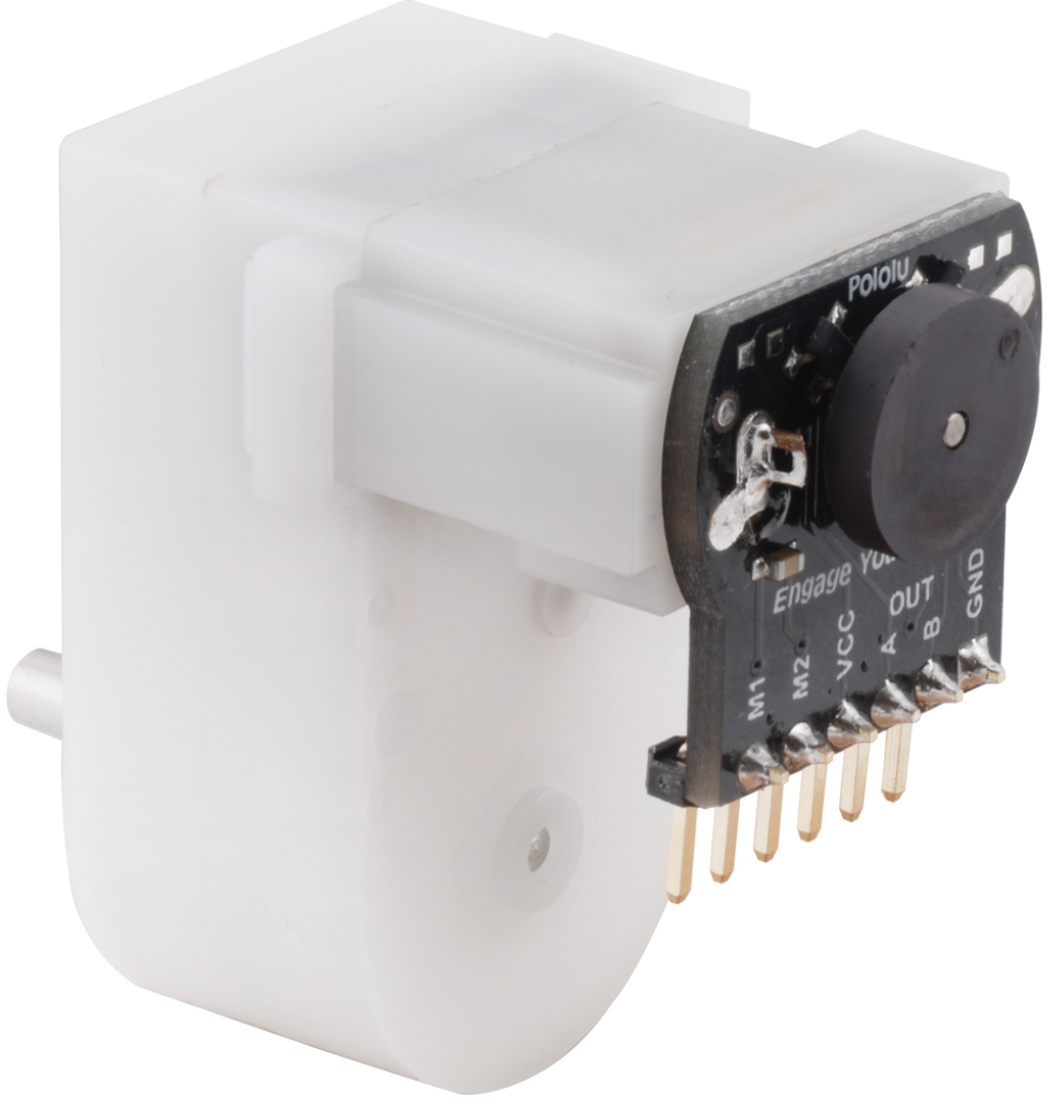 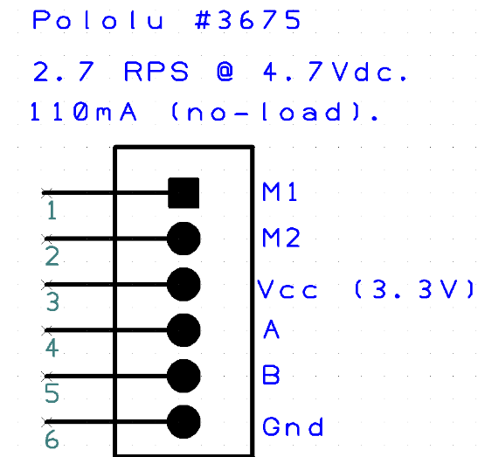

Figure 10.2. Hardware groups use Pololu item #3675. M1 and M2 connect to the DC motor and the other four wires are the tachometer. Do not ground A or B, they are outputs.

Figure 10.3 shows a possible data flow graph.



Figure 10.3. Option 1) Lab 10G data flow graph.

Student 4 creates a mechanism to visualize and control the system

Option 1) Student 4 implements Blynk

Option 2) Student 4 implements UART0/USB/PC/Python

Figure 10.4 shows a possible call graph.



Figure 10.4. Lab 10G call graph.

Option 2) replace Blynk with UART0/USB/PC/Python

## Student 1 Motor Interface

Choose Port-B[6] on the TM4C123 for the PWM output. The LM4F120 does not have hardware PWM. So, if you have an LM4F120 LaunchPad you will need to use one of the timers to create the PWM output. Use a 10k resistor into the gate to reduce transients. Use a 1N914 (any fast diode is ok) to remove back EMF caused by the V=L*dI/dt across the motor (see Figure 10.5). Connect M2 to +5V and use the IRLD024/IRLD120 to sink current from the M1 to ground. Refer to IRLD024/IRD120 interface in [**aLec42_DC_Motors.pptx**](https://www.dropbox.com/s/ez9kxdaawj3j3xy/aLec42_DC_Motors.pptx?dl=1).

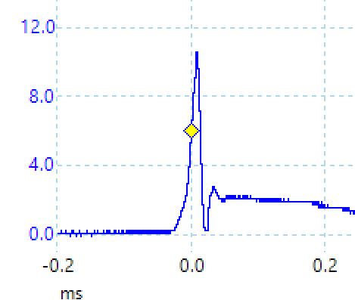 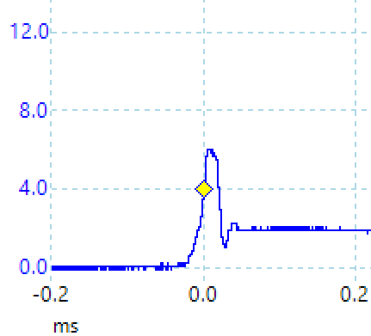

Figure 10.5. Voltage from drain to source (motor – to ground) when current is removed. The left response was measured without the 1N914 shunt diode and the response on the right was measured with the 1N914 shunt diode. The steady state 2-3V output after 0.05ms occurred because the pin was floating at the point in time

In order to choose a PWM period you will need to know the time constant of your motor. Figure 10.6 is measured speed as a function of time as PWM is increased from 25 to 50%. You can estimated the time constant of this motor to be 50 ms. Therefore if the PWM period is 1ms, the motor will only respond to the average power (duty cycle), and not to the individual high and low signals of the interface.

Figure 10.6. Step response of the DC motor used to estimate the time constant. Expect your measured speeds to be slower (this data was collected at 7.2V.)

## Student 2 Tachometer Interface

To interface the tachometer, connect VCC to 3.3V and GND to GND. Choose a TM4C123 pin that supports input capture interrupts. Use a 10k pullup to 3.3V for the tachometer output (A or B). You can use either A or B. You could interface both A and B to input capture if you wished to reduce the time to measure speed or if you wished to measure direction. [There are 12 tachometer pulses per rotation](https://www.pololu.com/product/3542). Figure 10.7 shows the tachometer output of 973.4 Hz, ~~which is 60*973.4/360 rpm = 162 rpm~~. If the motor spins from 0 to 162 RPM, then choose a fixed-point resolution of 0.1 or 0.01 RPM. Choose a resolution based on the ability of the tachometer to measure speed at 100 RPM.

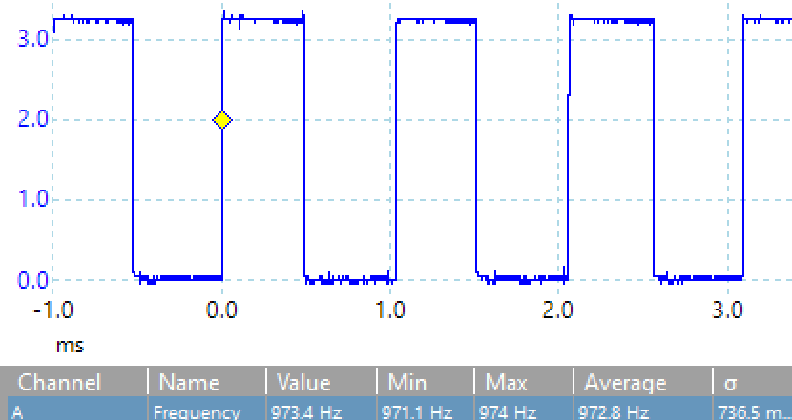

Figure 10.7. Tachometer output at full speed.

The tachometer interface may require filtering to improve SNR. However, be careful to minimize time delay. Time delays in the digital controller will cause the system to be unstable. For any digital filter measure the step response. A simple measure of filter delay is to make input go from …x,x,x,x,y,y,y,y… and determine many samples it takes for the output of the filter to reach x+(y-x)e-1. For example, the delay of a 3-wide median filter is 1 sample.

You will need a separate periodic timer interrupt to determine if the motor is spinning too slow to be accurate or not spinning at all.

## Student 3 Digital Controller Design

A closed loop feedback is required because not all motors are created equal. In Figure 10.8 we see the results from 8 different motors (the ones from the lab board, not this one however). One of the first steps in designing a digital controller is to make an estimate of motor speed in RPM versus PWM duty cycle. This curve will help estimate the range of speeds that your controller will be able to manage. In other words, what speeds correspond to duty cycles from 25 to 75%? Note: this response is highly dependent on friction. We expect the usable range to be around 50 to 120 RPM, but your motor may be different. You are free to control speed in rps or RPM as long as the fixed point resolution matches the tachometer error. The design progression is

1. Incremental (stable but slow)
2. Integral (stable, a little faster)
3. Proportional-integral (may be unstable, fast)

## Student 4 Blynk Control Interface or UART/Python Interface

Convert the Lab 4D Blynk code to provide variables to the PI control loop and display the key output values of the motor controller on the LCD. See figures 10.8, 10.12-10.15 below.

## Requirements Document

1. Overview

1.1. Objectives: Why are we doing this project? What is the purpose?

The objectives of this project are to design, build and test a brushed DC motor controller. The motor should spin at a constant speed and the operator can specify the desired set point. Educationally, students are learning how to interface a DC motor, how to measure speed using input capture, and how to implement a digital controller running in the background.

1.2. Process: How will the project be developed?

The project will be developed using the TM4C LaunchPad. The user will use switches or the UART to specify the desired speed of the motor as well as the “K” terms for the Proportional and Integral components of the PI controller. The system will be built on a solderless breadboard and run on the usual USB power. A hardware/software interface will be designed that allows software to control the DC motor. There will be at four hardware/software modules: motor controller output, tachometer input, digital controller, and user interface with switches, UART and LCD. The process will be to design and test each module independently from the other modules. After each module is tested, the system will be built and tested.

1.3. Roles and Responsibilities: Who will do what? Who are the clients?

EE445L students are the engineers and the TA is the client. Student 1 will design build and test the motor controller output. Student 2 will design build and test the tachometer input. Student 3 will design build and test the digital controller. Student 4 will design build and test the user interface with switches. All students will work performance measurements and tuning the controller. *(note to students: you are expected to make minor modifications to this document in order to clarify exactly what you plan to build. Students are allowed to divide responsibilities of the project however they wish, but, at the time of demonstration, both students are expected to understand all aspects of the design.)*

1.4. Interactions with Existing Systems: How will it fit in?

The system will use the microcontroller board, a solderless breadboard, and the DC motor shown above in Figure 10.2. The wiring connector for the DC motor is described in [**aLec42_DC_Motors.pptx**](https://www.dropbox.com/s/ez9kxdaawj3j3xy/aLec42_DC_Motors.pptx?dl=1).

1.5. Terminology: Define terms used in the document.

For the terms Proportional-Integral (PI) controller, PWM, board support package, back EMF, torque, time constant, and hysteresis, see textbook for definitions.

1.6. Security: How will intellectual property be managed?

The system may include software from TivaWare and from the book. No software written for this project may be transmitted, viewed, or communicated with any other EE445L student past, present, or future (other than the lab partner of course). **It is the responsibility of each team to keep its EE445L lab solutions secure.**

2. Function Description

2.1. Functionality: What will the system do precisely?

The palette for the Blynk App (Fig 10.8) will have the following 8 virtual pin components:

* Slider to control the desired motor speed
* Two sliders to control the “K” multiplier/divider for the Proportional term
* Two sliders to control the “K” multiplier/divider for the Integral term
* RPS Value display
* PWM Duty Cycle Control Value (U)
* PI Error Value (E)
* Optional: Proportional and Integral Term values

Remember to delete the Widgets from Lab 4 so that you don’t have to buy new tokens for this Lab.

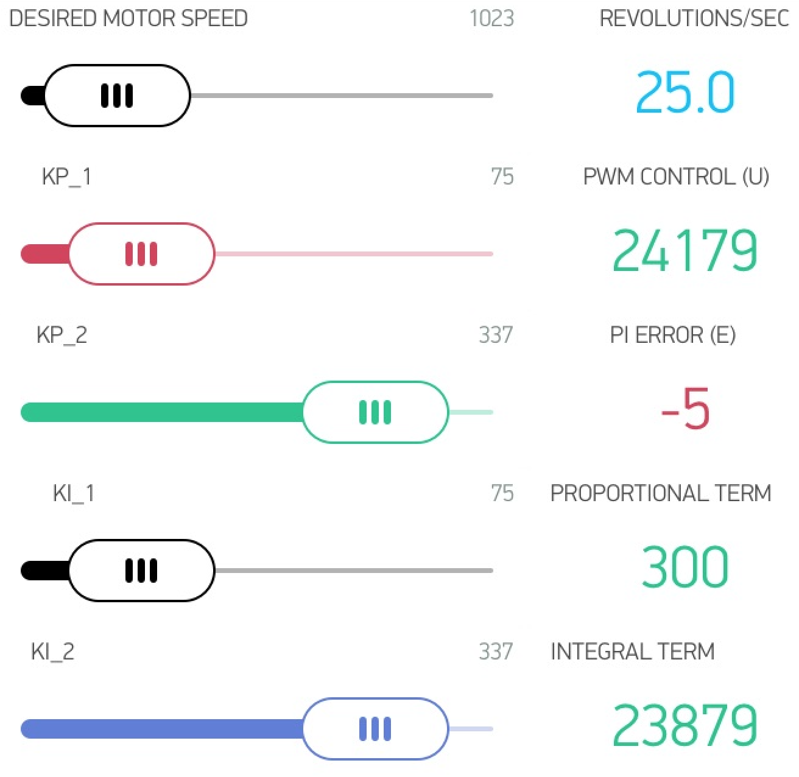

Figure 10.8 Blynk App palette (feel free to remove the Motor RPS so you’ll not have to buy tokens) Feel free to make this user interface however you wish. You may also have to delete the Lab 4 Blynk app

The PI control equation should be in this form:

MotorSpeed = rps/40; // Set the Motor Speed

P = (Kp1 * E)/Kp2; // Proportional term

if(P < 300) P = 300; // Minimum PWM output = 300

if(P >39900) P = 39900; // Maximum PWM output = 39900

I = I + (Ki1 * E)/Ki2; // SUM(KiDt)

if(I < 300) I = 300; // Minimum PWM output = 300

if(I >39900) I = 39900; // Maximum PWM output = 39900

U = P + I; // Calculate the actuator value

if(U < 300) U=300; // Minimum PWM output

if(U >39900) U=39900; // 3000 to 39900

PWM0A_Duty(U); // Send to PWM

The motor speed should start out at zero RPS. Once the desired motor speed slider is adjusted the motor should start. (Note to students: feel free to change how the set point is established, and feel free to increase or decrease the maximum speed in accordance to how it actually works.)

Both the desired and actual speeds should be plotted on the color LCD as a function of time similar to Figure 10.11 The actual speed should also be graphically shown on the Blynk App. (note to students: feel free to specify exactly how the data is displayed. For example, you could but do not have to add numerical outputs).

2.2. Scope: List the phases and what will be delivered in each phase.

Phase 1 is the preparation; phase 2 is the demonstration; and phase 3 is the lab report. Details can be found in the lab manual.

2.3. Prototypes: How will intermediate progress be demonstrated?

A prototype system running on the LaunchPad and solderless breadboard will be demonstrated. Progress will be judged by the preparation, demonstration and lab report.

2.4. Performance: Define the measures and describe how they will be determined.

The system will be judged by three qualitative measures. First, the software modules must be easy to understand and well-organized. Second, the system must employ a PI controller running in the background. There should be a clear and obvious abstraction, separating the state estimator, user interface, the controller and the actuator output. Backward jumps in the ISR are not allowed. Third, all software will be judged according to style guidelines. Software must follow the style described in Section 3.3 of the book *(note to students: you may edit this sentence to define a different style format)*. There are three quantitative measures. First, the average speed error at a desired speed of 60 RPM will be measured. The average error should be less than 5 RPM. Second, the step response is the time it takes for the new speed to hit 100 RPM after the set point is changed from 50 to 100 RPM. Third, you will measure power supply current to run the system. There is no particular need to minimize controller error, step response, or system current in this system.

2.5. Usability: Describe the interfaces. Be quantitative if possible. Describe the how the Blynk App will control the motor.

2.6. Safety: Explain any safety requirements and how they will be measured.

We expect the motor current to be less than 120 mA. Please place a current probe on the motor interface the first couple of time you run the motor to make sure you have wired it correctly. However, under heavy friction this current could be 2 times higher. Therefore, please run the motor unloaded. Connecting or disconnecting wires on the protoboard while power is applied will damage the microcontroller. Operating the circuit without a snubber diode will also damage the microcontroller.

3. Deliverables

3.1. Reports: How will the system be described?

A lab report described below is due by the due date listed in the syllabus. This report includes the final requirements document.

3.2. Audits: How will the clients evaluate progress?

The preparation is due at the beginning of the lab period on the date listed in the syllabus.

3.3. Outcomes: What are the deliverables? How do we know when it is done?

There are three deliverables: preparation, demonstration, and report. (Note to students: you should remove all notes to students in your final requirements document).

## Preparation (do this before your lab period)

1. Copy and paste the requirements document from this document. Edit it to reflect your design.
2. Edit the [Lab_10G.sch](https://www.dropbox.com/sh/2lzrbx88r8cgw05/AADl2iDcrez1SNAoDAh33-Kya?dl=1) file showing the interface to the motor and to the tachometer. Make sure your TA approves the design before connecting it to the microcontroller. Include pin numbers and resistor/capacitor types and tolerances. Power the motor from the USB +5V and not +3.3V. This interface will require a 1N914 snubber diode. If do not properly connect this diode, the back EMF will destroy your microcontroller and possibly your laptop if it is connected to the TM4C board.

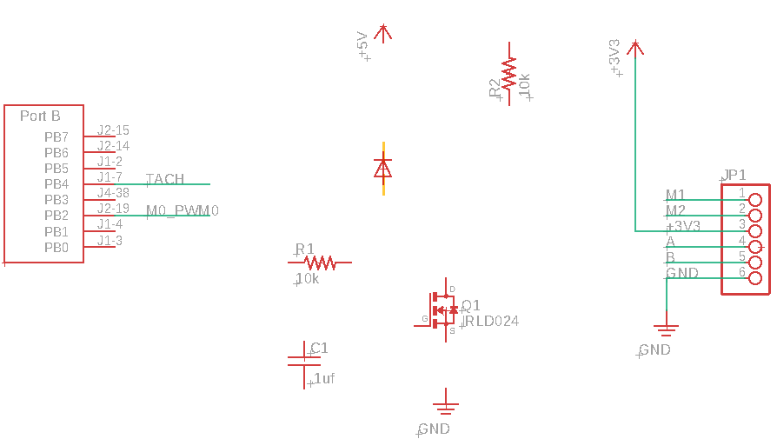

1. Design four software modules that implement the digital controller. A “syntax-error-free” version of the header files is required as preparation. This will be checked off by the TA at the beginning of the lab period. If you wish to see more timer and PWM examples, see the EE445M sensor board and motor board starter projects (see starter files above).

## Student 1 Procedure (do this during your lab period)

With an ohmmeter, measure the resistance of the motor coil. The very fast turn-off times of the digital transistors can easily produce large back EMF voltages, so please test the hardware before connecting it to the microcontroller. Make sure your TA checks your hardware diagram before connecting it to the microcontroller.

Build the hardware interface to the motor. However, before connecting it to the microcontroller, you must use a simple switch to simulate a PWM output of 100%. Connect a current meter in series with the motor current path. Measure the motor current at full speed (100% duty cycle). Please contact your professor or TA if this current is vastly different from 120mA. Measure also the voltage drop across the motor at full speed (100% duty cycle). Call this full speed motor voltage *Vm*. The voltage drop across the MOSFET *VDS* should be much less than 1V. Note: *VDS* + *Vm* should equal 5V.

Test the PWM output with a scope or logic analyzer before connecting it to the motor. Write software so a switch causes the PWM to cycle through 10%, 30%, 50%, 70% and 90%.

Remove the switch, connect the PWM to the motor circuit, and reconnect the current meter in series with the motor current path. Using the PWM output in open loop fashion measure the motor current at duty cycles 10%, 30%, 50%, 70% and 90%. Do this under no load. Estimate the average motor voltage as *duty*\**Vm*. Create a graph similar to Figure 10.9 below. Plot the straight line suggested by the ohmmeter measurement of motor resistance.

Figure 10.9 was measured with the Lab board motor, so expect your measurements to be different. However, the motor does not behave like a simple resistor.

Figure 10.9: The current to the Lab board DC motor is plotted versus applied voltage. Notice the DC motor does not behave like a resistor. This response will also be a function of the mechanical torque (or friction) applied to the shaft.

## Student 2 Procedure (do this during your lab period)

Build the hardware interface to the tachometer. Using a scope (real or TExaSdisplay), verify the tachometer interface generates a digital (0V and 3.3V) signal like Figure 10.7. Speed measurement must occur in the background using an input capture and periodic interrupt.

Using the PWM output in open loop fashion measure the motor speed at duty cycles 10%, 30%, 50%, 70% and 90%. Do this under no load. Estimate the average motor power as *duty*\**Im*\**Vm*. Create a graph similar to Figure 10.10 below.

Figure 10.10: The motor speed is plotted versus applied power on seven different motors. Power is motor voltage multiplied by motor current multiplied by PWM duty cycle. Motor speed (RPS) is tachometer frequency (Hz) divided by 4. Notice at 100 mW, these DC motors do not spin at all. Also notice the variability between these seven motors. This response will also be a function of the mechanical torque (or friction) applied to the shaft.

## Student 3 Procedure (do this during your lab period)

After you are sure the motor and tachometer interfaces are operating properly, test a simple incremental controller, see Figure 10.11. Choose a PWM period, a range of usable speeds, and a controller rate consistent with the data collected in the above two procedures.



Figure 10.11: Incremental controller. Change the +3, -3, +100, -100, 14898 constants.

Debug the integral motor controller. Consider calculating speed as a decimal fixed-point number in 0.1 or 0.01 RPM. The periodic interrupt-driven background thread will execute the digital controller, while the foreground thread initializes the system then performs human interface. An integral controller is pretty stable. If the speed oscillates wildly (all stop- full speed) then decrease the controller constant. If it is VERY slow to respond, increase the constant.

## Student 4 Procedure (do this during your lab period)

Student 4 creates a mechanism to visualize and control the system

Option 1) Student 4 implements Blynk

Option 2) Student 4 implements UART0/USB/PC/Python

Option 1) Setup the user interface that runs in the main program. See requirements document for details. Your system performance display on the LCD should be similar to Figure 10.12 through 10.15 and the YouTube video, <http://youtu.be/ug-ZlOSbb4M>.

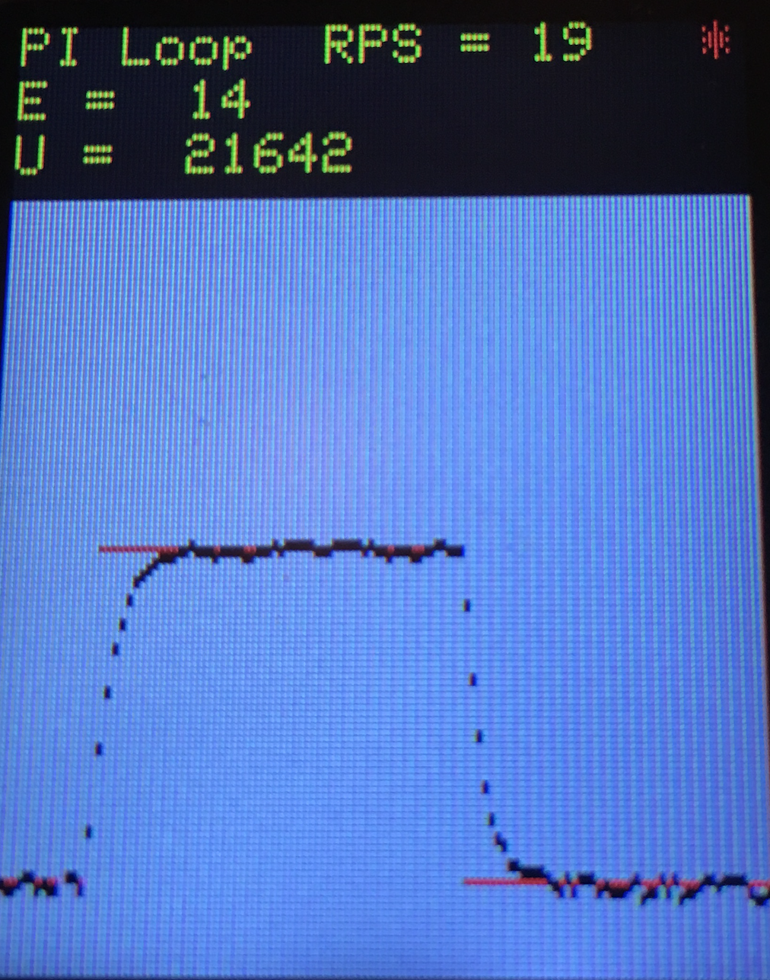

Figure 10.12: Measured and desired speeds are plotted versus time as the set point is increased from 20 to 50 RPS. NOTE: This is an optimally damped PI Loop (Lab board motor)

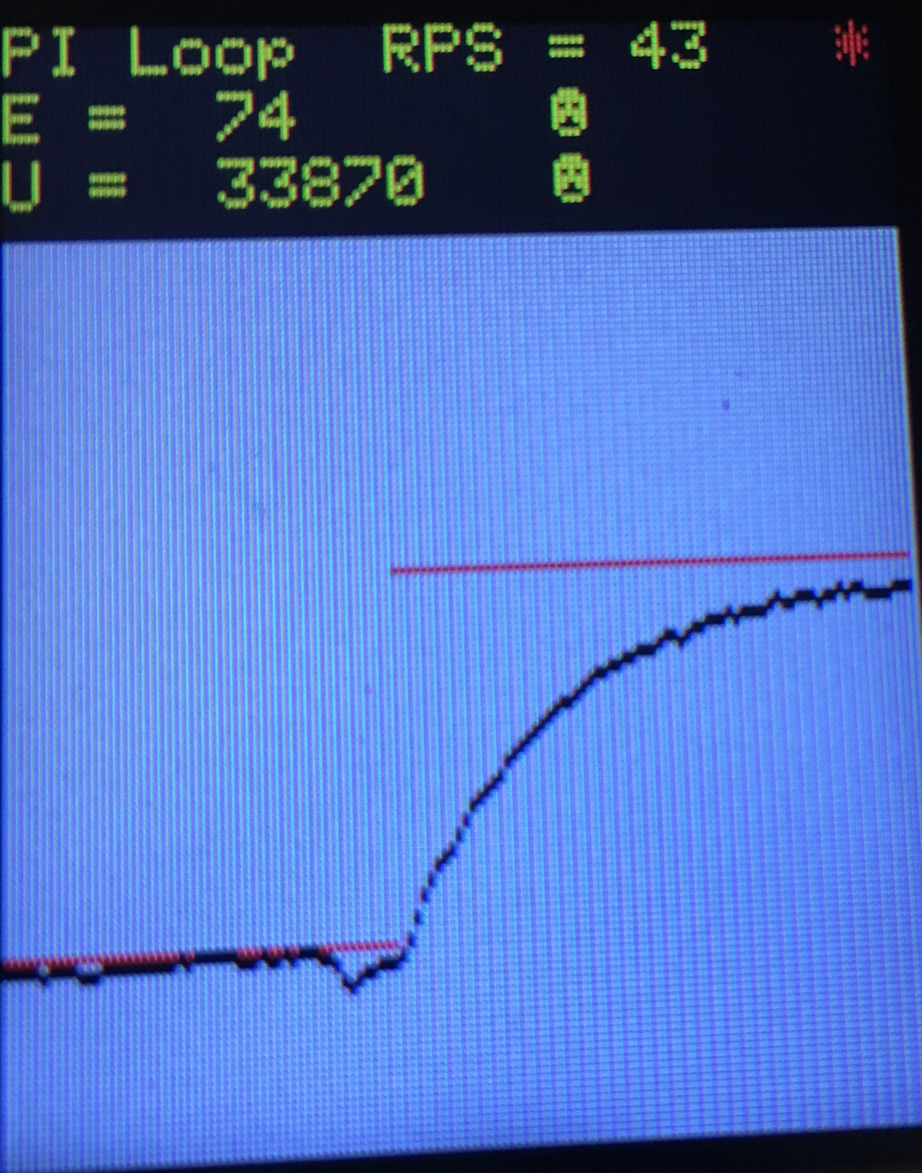

Figure 10.13: Over-damped PI Loop

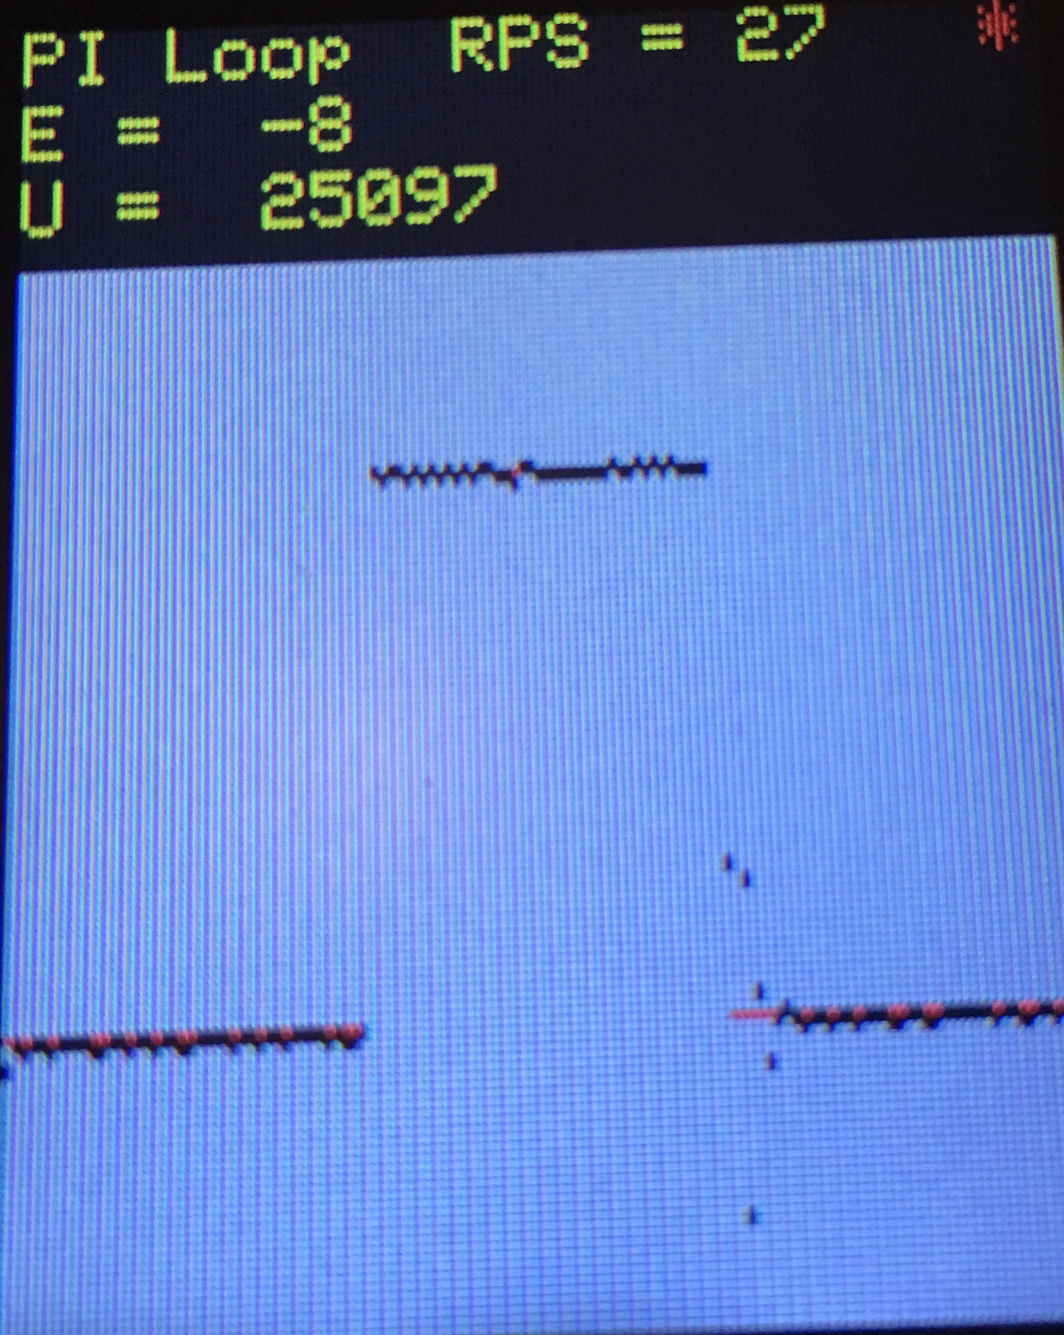

Figure 10.14: Under-damped PI Loop

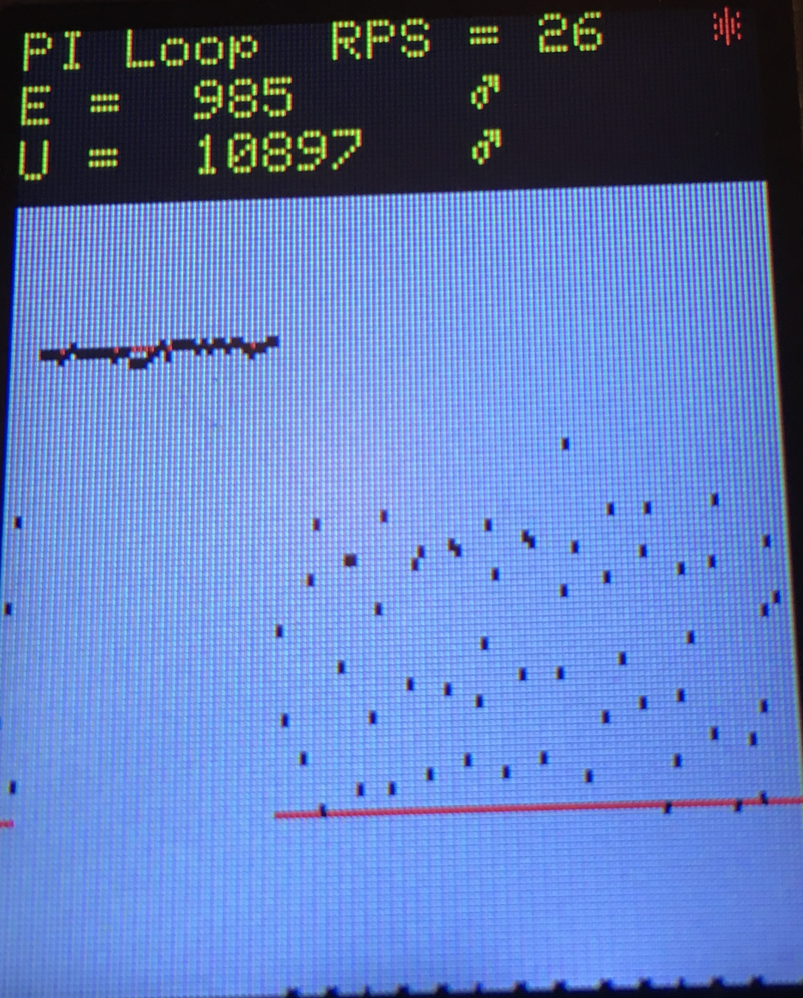

Figure 10.15: Unstable PI Loop

The Blynk or Python user interface should facilitate changing controllers and controller parameters. You should be able to demonstrate without recompiling.

## Student-all Procedure (do this during your lab period)

Measure the maximum time to execute each of your ISRs.

For each of the three controllers, what is the average controller error (difference between desired and actual speed)? *The PI controller is optional.*

For each of the three controllers, what is the approximate time it takes the speed to stabilize after the set point is increased from 40 to 90 RPM? Feel free to change these two set points has appropriate for your system. You do not need to tweak the system to minimize error or response time.

## Deliverables (exact components of the lab report)

1. Objectives (final requirements document)
2. Hardware Design (PCB Artist file)

DC motor and tachometer interfaces, showing all external components

LCD and switch interfaces, showing all external components

Include both these in a schematic

1. Software Design (upload your files as instructed by your TA)

Make sure to include units on all your software variables

Make a clear distinction between variables used for debugging and variables needed in the controller

Data flow and call graph: copy Figures 10.3 and 10.4, and edit as necessary

1. Measurement Data (underlined sections of the lab manual)

Procedure 1) Give the voltage, current, and resistance measurements. Plot motor current vs *duty*\**Vm*.

Procedure 2) Typical plot of the tachometer like Figure 10.7. Motor speed vs PWM. Plot of motor speed vs power, like Figure 10.8.

Procedure 4) We define **locking** as the condition when the error eventually goes to approximately zero. Four screen shots of the hardware in operation -> switching from minimum speed to

maximum speed or vice versa:

a) Normal operation – optimal response time (locking). Fig 10.11

b) Slow loop response time (locking) Fig 10.12

c) Fast loop response time (locking) Fig 10.13

d) Unstable (unable to lock) Fig. 10.14

Procedure-all) Specify the maximum time to execute once instance of the ISR. Determine the percentage time required to run all ISRs.

Procedure-all) Specify the average controller error for three controllers

Procedure-all) Specify the approximate response time for three controllers

1. Analysis and Discussion (give short 1 or two sentence answers to these questions)
2. What is torque? What are its units?
3. Draw an electrical circuit model for the DC motor coil and explain the components. Use this circuit model to explain why the current goes up when friction is applied to the shaft
4. Explain what parameters were important for choosing a motor drive interface chip (e.g., IRLD024/IRD120). How does your circuit satisfy these parameters?
5. You implemented an integral controller because it is simple and stable. What other controllers could you have used? For one other type of controller how would it have been superior to your integral controller.
6. It the motor is spinning at a constant rate, give a definition of electrical power in terms of parameters of this lab? Research the term “*mechanical power*”. Give a definition of mechanical power. Are the electrical power and mechanical power related?

## Checkout (show this to the TA)

You should be able to demonstrate correct operation of the DC motor system. Be prepared to describe how your motor interface works. Demonstrate debugging features that allow you to visualize the software behavior. Show the TA the four modes specified in the Deliverables Section-4: Normal operation, Slow loop response time, Fast loop response time and Unstable mode.

All software and report files must be uploaded as instructed by your TA.

## Hints

1. You should use a periodic interrupt to determine if the motor is stopped or spinning very slowly.
2. The USB +5V regulated supply is specified to 500 mA total current. We strongly suggest you do not mechanically load the motor. It runs 120 mA unloaded, but much larger if you load the motor. If your PC disconnects you, then you will need to power cycle your computer and restart the OS.